**Write the following basic python programming on conditional and looping statements**

1. Write the program for the basic condition:  
   1.1) Get the mark as input from the user.  
   1.2) Input should be of float data type.  
   1.3) Based on the mark calculate the Grade

print("Enter the Mark");

mark=float(input());

if mark>=95:

print("S");

elif mark>=90:

print("A");

elif mark>=80:

print("B");

elif mark>=70:

print("C");

elif mark>=60:

print("D");

elif mark>=50:

print("E");

else:

print("Fail");



1. Write the program for the basic condition:  
   2.1) Get the number as input from the user  
   2.2) Print the decreasing sequence from the number till 1

print('Enter the Number');

a=int(input());

i=1;

while(i<=a):

print(a);

a-=1;

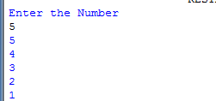

1. Write a program to read your name as input and display each alphabet of your name.

print('Enter number');

data=input();

for t in data:

if(t=='o'):

pass;

print(t);

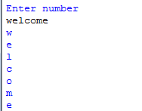  
4. Write a program to read your name as input and display each alphabet of your name till 'o' appears.

print('Enter number');

data=input();

for t in data:

if(t=='o'):

break;

print(t);

else:

print('loop completed');

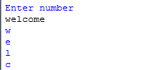

5. Write a program to read your name as input and display each alphabet of your name except 'o'.

print('Enter number');

data=input();

for t in data:

if(t=='o'):

continue;

print(t);

